
General Overview of Regional Anesthesia

Patient Information

Providing our patients with state of the art anesthesia and pain management care. Utilizing the latest techniques in anesthesia to ensure a successful and as pain free a procedure as possible.

The Anesthesia Care Team


The role of the anesthesia care team in your surgery is to maintain and regulate your critical life functions, such as your heart rate, blood pressure and breathing. Your anesthesia care team will meet with you prior to your surgery to discuss the type of anesthesia that will be used and to discuss your past medical and surgical history.

The anesthesia team is comprised of Faculty physicians, Resident physicians and Certified Nurse Anesthetists (CRNAs). The anesthesia team will work together to develop the best anesthesia care plan to meet your specific needs.

How is Regional Anesthesia different from General Anesthesia?

In general anesthesia, you are unconscious and have no awareness or other sensations.
In regional anesthesia, your anesthesiologist makes an injection near nerves to numb the area of your body that requires surgery and you often have a choice to receive general anesthesia or be sedated. You, your anesthesiologist and surgeon will determine if regional anesthesia is right for you.
What types of surgical procedures would be appropriate for Regional Anesthesia?

If there are no medical contraindications, anesthesiologists are able to perform regional anesthesia techniques for a wide variety of surgical procedures. Some examples include:

• Gastrointestinal (stomach);
• Hepatic (liver);
• Gynecology (female reproductive organ);
• Orthopedics (bone and joint);
• Thoracic surgery (chest);
• Urology (kidney, prostate, and bladder);
• Vascular surgery (blood vessels
What are the benefits of a regional anesthesia?

- Faster awakening;
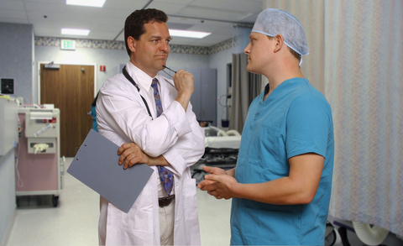
- Up to 3 days of pain relief with a peripheral nerve catheter placement
- 8-24 hours of pain relief after a single injection;
- Better pain control than narcotics alone;
- Less need for narcotics and therefore less side effects from these medicines like nausea and constipation;
- You may go home earlier after surgery;
- Easier breathing resulting from better pain control;
- Easier or earlier participation in physical therapy post-surgery.

What are the risks of Regional Anesthesia?

Significant injuries can occur but are extremely rare. Such injuries include infection, injury to blood vessels, reaction to medications, temporary or permanent loss of sensation and/or weakness. If you have any concerns, you should talk to your anesthesiologist prior to your surgery.

